**UAT ICSK**

**Type of application** – web app

- **Application framework, version used, Database used, size of App data** : php 7, mysql 5.3

- **Current infrastructure on which the website is running** -

|  |  |
| --- | --- |
| **1** | GB RAM |
| **1** | CPU Core |
| **25** | GB SSD Storage |
| **1** | TB Transfer |
| **40** | Gbps Network In |
| **1000** | Mbps Network Out |

- **OS** cent os 7

- **Actual Average CPU & RAM usage % of current hosting**

- **Actual bandwidth(data transfer) usage per month**

- **Average No. of users at a time and monthly**

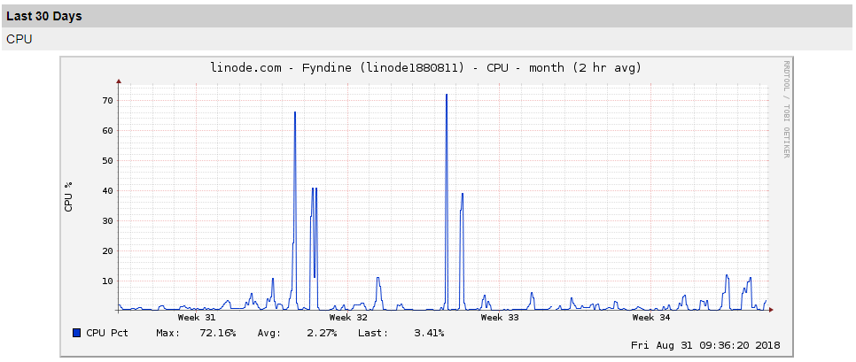

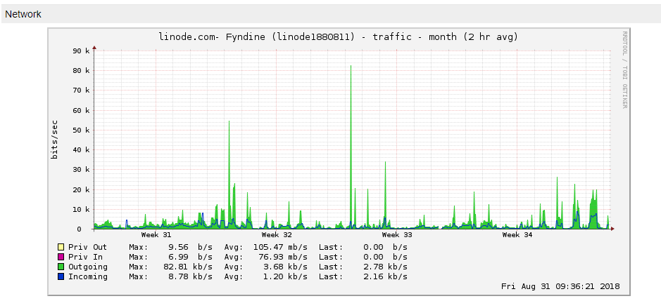

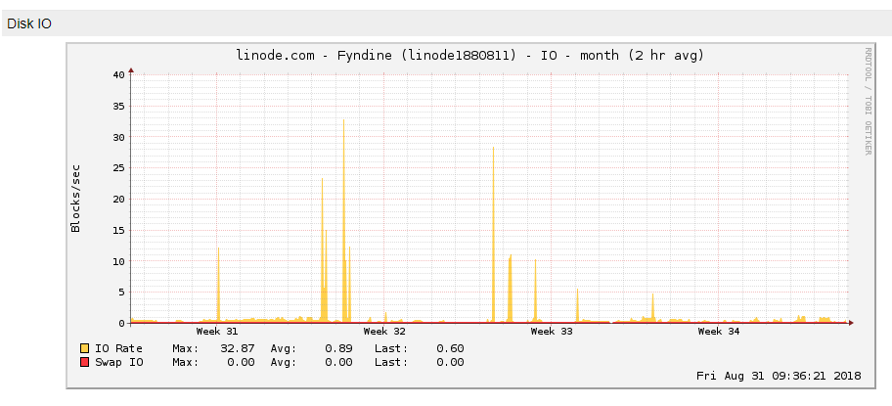

**KVG**

**Type of application** – web app

**Application framework, version used, Database used, size of App data** : php 7, mysql 5.3

**Current infrastructure on which the website is running** –

|  |  |
| --- | --- |
| **2** | GB RAM |
| **1** | CPU Core |
| **50** | GB SSD Storage |
| **2** | TB Transfer |
| **40** | Gbps Network In |
| **2000** | Mbps Network Out |

**OS** cent os 7

**Actual Average CPU & RAM usage % of current hosting**

**Actual bandwidth(data transfer) usage per month**

**Average No. of users at a time and monthly**

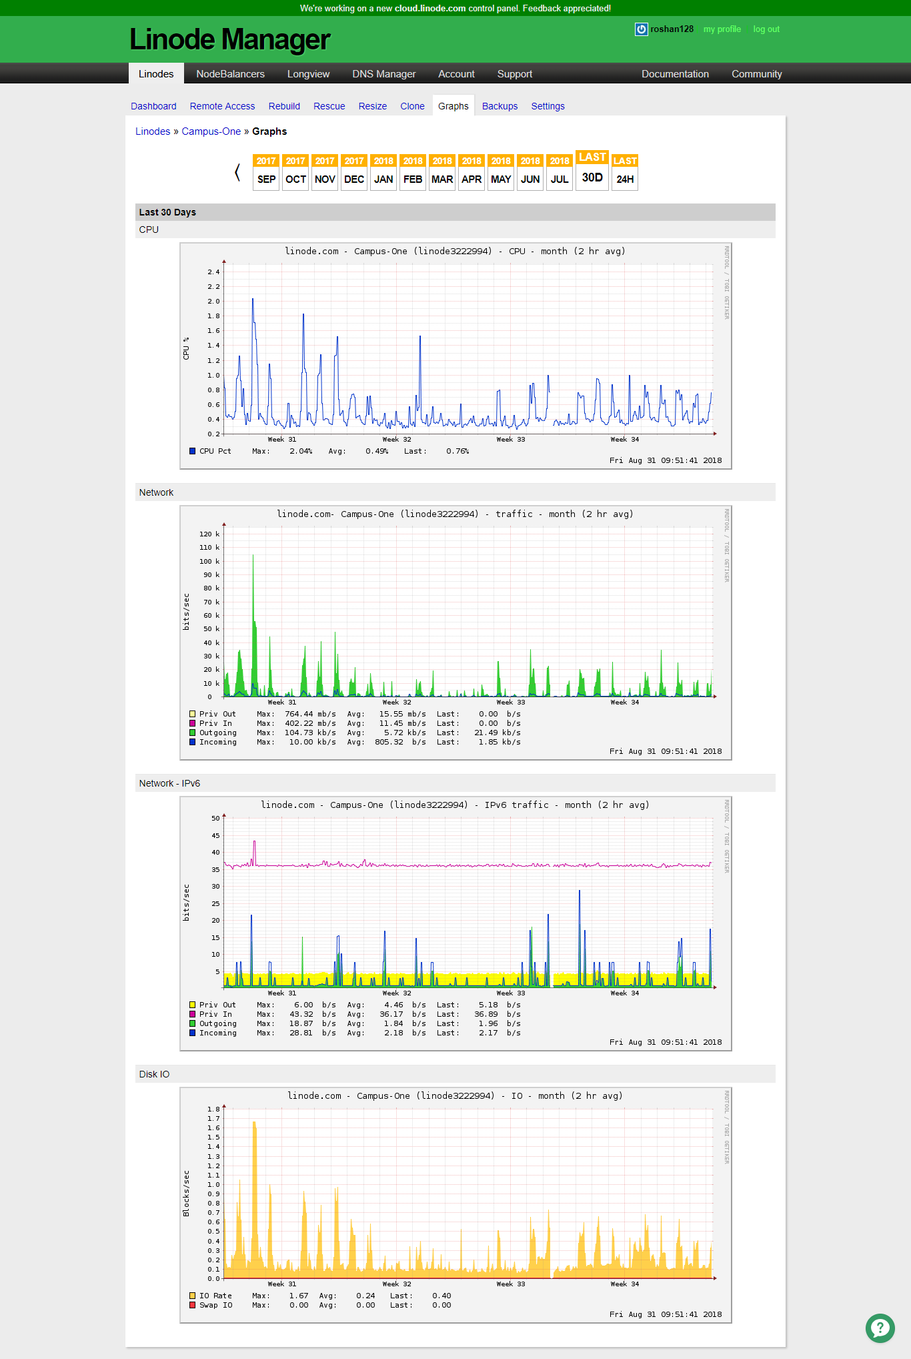

**Watch Me**

**Type of application** – web

**Application framework, version used, Database used, size of App data** : php 7, mysql 5.3

**Current infrastructure on which the website is running** –

**1** GB RAM, **1** CPU Core, **25** GB SSD Storage, **1** TB Transfer, **40** Gbps Network In, **1000** Mbps Network Out

**OS** cent os 7

**Actual Average CPU & RAM usage % of current hosting**

**Actual bandwidth(data transfer) usage per month**

**Average No. of users at a time and monthly**

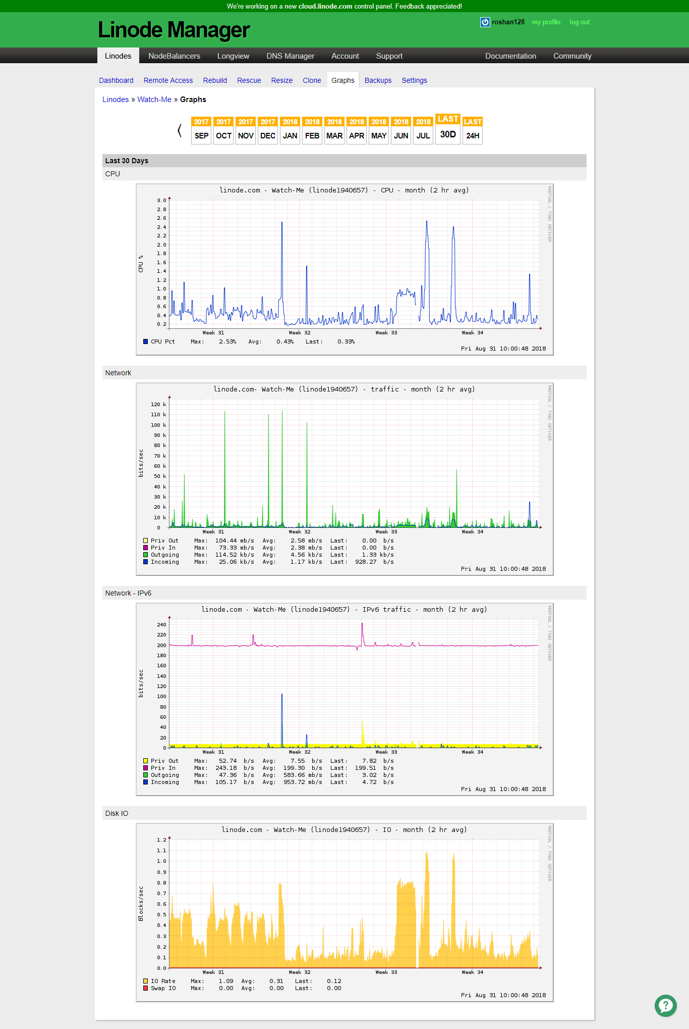

**Axon Server**

**Type of application** – web

**Application framework, version used, Database used, size of App data** : php 7, mysql 5.3

**Current infrastructure on which the website is running** –

* 2 CPU
* 1,024 MB RAM
* 250,000 files
* 100 entry processes

**OS** cent os 6

**Actual Average CPU & RAM usage % of current hosting**

**Actual bandwidth(data transfer) usage per month**

**Average No. of users at a time and monthly**

**(statistics file is separately attached)**

**ICSK Server**

**Type of application** – web

**Application framework, version used, Database used, size of App data** : php 7, mysql 5.3

**Current infrastructure on which the website is running** –

**4 CPU Cores**

**8 GB** RAM

**200 GB** storage

**OS** cent os 6

**Actual Average CPU & RAM usage % of current hosting**

**Actual bandwidth(data transfer) usage per month**

**Average No. of users at a time and monthly**

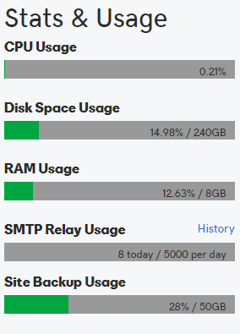

**(files attached)**

**KwtPet**

**Type of application** – web

**Application framework, version used, Database used, size of App data** : php 7, mysql 5.3

**Current infrastructure on which the website is running** –

|  |  |
| --- | --- |
| **48** | GB RAM |
| **2** | CPU Cores |
| **40** | GB SSD Storage |
| **6** | TB Transfer |
| **40** | Gbps Network In |
| **6000** | Mbps Network Out |

**OS** cent os 7

**Actual Average CPU & RAM usage % of current hosting**

**Actual bandwidth(data transfer) usage per month**

**Average No. of users at a time and monthly**

(attached)